Weekly Project Meeting Minutes

**Date of meeting(s):** March 27th, 2020

Group members (Name, ID)

* Yi Zhou 0730368
* Tejas Mahesh Patel: 0730241
* Soorya Suresh: 0735168
* Mohsin Meghjani: 0730241
* Seong Kyoung: 0725164
* Rajwinder Kaur: 0732989

**Specific Activities:**

During the last week, we were working in python file and try to predict the model as well.

* We converted the string Date column into one new date column in datetime format.
* We also drop the Date column and working with the new date column.
* In our dataset we do not have missing values.
* We did plot which shows the moving average on the 4 different days.

**Specific Output from prior week:**

* Main Goals: our goal is to find out the cryptocurrency which have the low volatility.
* We made the date as index so that its easy for visualization
* We converted the string to float datatype
* We plot the moving average for 9,15 and 21 days where moving average 9 is the best.
* The plot represents seasonality where it shows repeating short term cycle in the series.

**Drop Date column:**

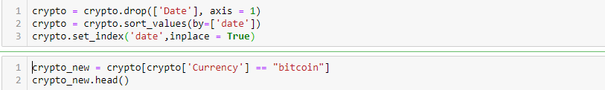

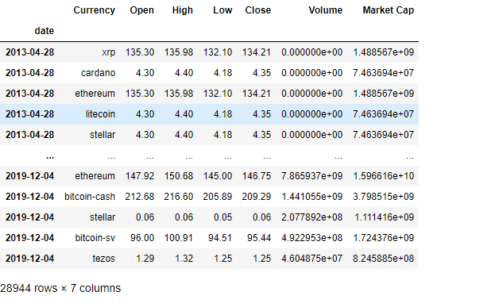

**Plot**

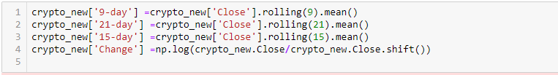

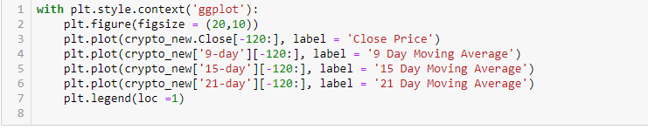

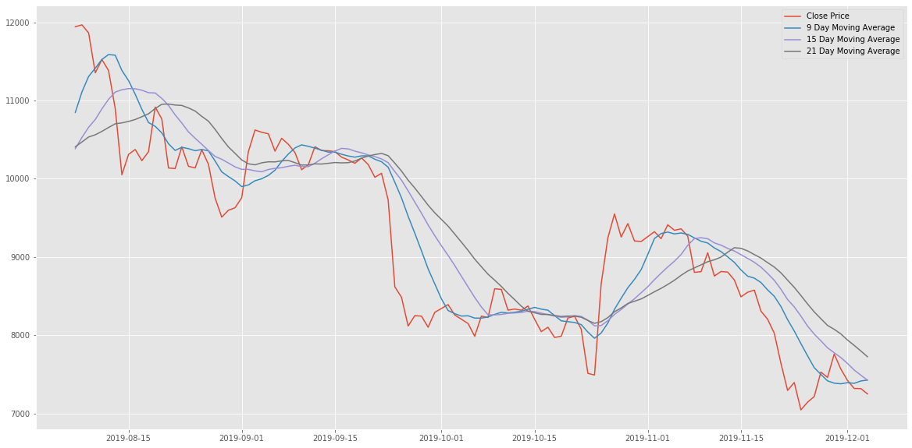

**On Target:**

* green: everything on track for completion by due date.

**Activities by group members:** All the group member working together.

Yi Zhou, Soorya, Rajwinder and Mohsin is working on report and Tejas and Seoung is doing the modeling.

**Challenges:**

* Our main challenge is to find the right algorithm for prediction.

**Planned Activities for coming week:**

* We will work on the model which gives us a right prediction on our dataset.

**Data source:** [**https://www.kaggle.com/philmohun/cryptocurrency-financial-data**](https://www.kaggle.com/philmohun/cryptocurrency-financial-data)

